Welcome!
Date
Name
Spouse
Address
City
State Zip _________
Email

Please Contact By
❑ Card  Phone  Visit

Telephone Best Time to Call
Home ______________
Work ______________

Guest: First Time Second Time
Are you a church member: yes no
Church
City, State

Circle Appropriate Age/Grade Group(s)
Preschool: Ages: B-1 2-3 4-5
Children: Grades: K 1 2 3 4 5 6
Youth: Grades: 7 8 9 10 11 12
Adults: Ages:18-29 30s 40s 50s 60s+

How did you learn about our church?
Newspaper Friend Yellow Pages Mail
Other

I am a guest of:

New in the Community? Yes No
Names & ages of children at home
WELCOME NEW MEMBERS:

Ben & Mary Quinn

1663 CR A, Lexington
512-273-2520
CONGRATULATIONS
Cleyon & Geneva Davis:

The adoption of “Nate” by Scott & Stacey is now official & finalized. They are joyfully thanking & praising God.

Weekly Service & Activity Schedule
February 16th, 2014
9:45 a.m. Sunday School
11 a.m. Morning Worship
Following Services Valentine Banquet & Concert

Week of February 17 – February 22
Wednesday, 6:30 p.m. Youth Activities
Wednesday, 6:45 p.m. Adult Prayer & Bible Study
Wednesday, 7:30 p.m. Praise Team Rehearsal
Friday-Saturday HLCCC Ladies Retreat



Upcoming Events
February
16 Valentine’s BBQ Dinner and Concert
21-22 Ladies Retreat
27 Adult Fellowship

Birthday & Anniversary Recognitions will occur on the final Sunday of each month.

Knobbs Springs Baptist Church

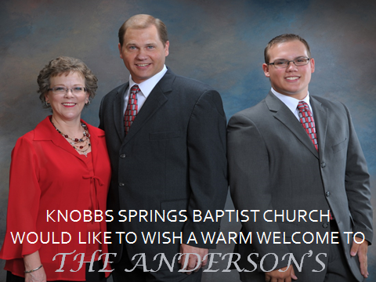

February 16, 2014

Church Information:

KnobbsSpringsBC.com KnobbsSpringsBaptist@gmail.com
1662 CR 305, McDade, Texas 78650 512-273-2743
Brother Dwight Reagan 512-247-6448
Kimberly Tabor, Office Manager 512-698-2804

